BIG DATA 07
Practical Assignment Portfolio
Assignment 3 — Continuous Stream Processing
Student Name | Hayagriva Boodhoo
Student ID | 2025_20379_6980
Cohort | BDA 7
Dataset | US Air Quality Index (US_AQI.csv)
Technologies | PySpark Structured Streaming, Kafka, Redis, Streamlit, Plotly
Submission Date

1. Dataset Description
The dataset used for this assignment is the US Air Quality Index (AQI) dataset (US_AQI.csv), sourced from Kaggle. It contains daily AQI measurements collected from monitoring stations across the United States, covering multiple cities and states with geographic coordinates.

Property | Detail
File Name | US_AQI.csv
Total Rows | ~50,000+
Key Numeric Field | AQI (0–500)
Date Column | Date (YYYY-MM-DD)
Categorical Fields | state_name, city_ascii, Category, Defining Parameter
Geographic Fields | lat, lng, population, density

AQI Range | Band | Health Implication
0 – 50 | Good | Air quality is satisfactory
51 – 100 | Moderate | Acceptable; some pollutants may concern sensitive groups
101 – 150 | Unhealthy for Sensitive Groups | Sensitive groups may experience effects
151 – 200 | Unhealthy | Everyone may begin to experience effects
201 – 300 | Very Unhealthy | Health alert — everyone may experience serious effects
301 – 500 | Hazardous | Health warning of emergency conditions

2. Environment Setup
All infrastructure was deployed using Docker and Docker Compose. Five containers were configured on a shared internal network (aqi-network), ensuring all services communicate by container name.

Container | Image | Role
aqi-zookeeper | confluentinc/cp-zookeeper:7.5.0 | Kafka coordination service
aqi-kafka | confluentinc/cp-kafka:7.5.0 | Message broker — holds aqi-stream topic
aqi-redis | redis:7-alpine | In-memory store for windowed results
aqi-spark-master | apache/spark:3.5.0 | Spark cluster master node
aqi-spark-worker | apache/spark:3.5.0 | Spark cluster worker node

Screenshot 1 — docker ps: all 5 containers running and healthy
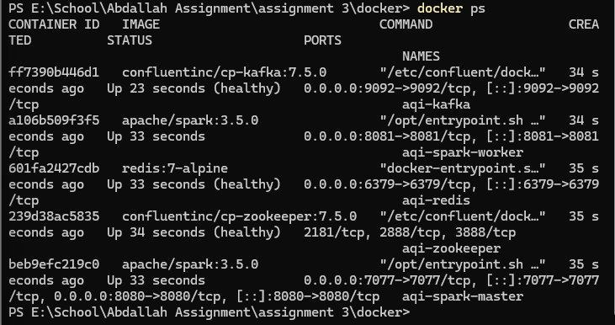

3. Task 1 — Kafka Replay Producer (4 Marks)

3.1 Objective
Write a Python script that reads the dataset row by row and publishes each record as a JSON message to the Kafka topic aqi-stream at a controlled rate, looping back to the start when the dataset ends — simulating a continuous live data feed.

3.2 Implementation
- kafka-python-ng==2.2.3 used for Python 3.12 compatibility
- All configuration stored in environment variables — never hardcoded
- stream_csv() generator loops indefinitely using while True
- build_message() validates each row and computes the AQI classification band
- Malformed rows skipped with warning log — robust error handling
- Every 100 messages: flush and log state, city, AQI value, and band

3.3 Producer Loop
def stream_csv(path: str) -> Generator[dict, None, None]:
while True: # loop forever — simulates infinite live stream
with open(path, newline='', encoding='utf-8') as f:
for row in csv.DictReader(f):
yield row

Screenshot 2 — Producer terminal: continuous rows publishing to Kafka with AQI band classifications
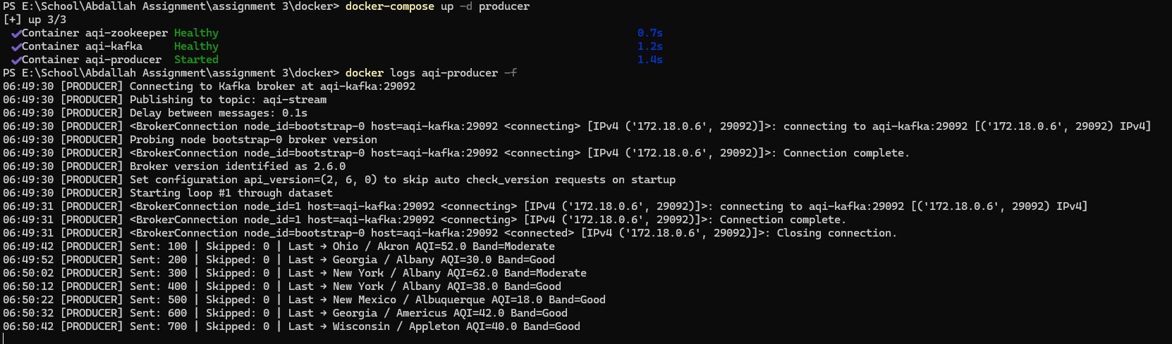

4. Task 2 — PySpark Structured Streaming Job (10 Marks)

4.1 Objective
Build a PySpark Structured Streaming application that reads from the Kafka topic, parses JSON messages, applies tumbling time window aggregations grouped by state, classifies each result into AQI severity bands, and writes results to Redis using a foreachBatch sink.

4.2 Pipeline Steps
- Read from Kafka topic aqi-stream using readStream with startingOffsets=latest
- Parse raw JSON bytes into a structured DataFrame using MESSAGE_SCHEMA
- Convert Unix timestamp to event_time using to_timestamp(from_unixtime(...))
- Apply withWatermark on event_time to handle late-arriving events
- Apply tumbling window groupBy(window(event_time, '30 seconds'), state)
- Compute avg_aqi, max_aqi, min_aqi, and record_count per window per state
- Classify each windowed result using classify_aqi() into one of 6 EPA bands
- Write to Redis using writeStream.foreachBatch(write_to_redis)

4.3 Window Aggregation Fields
Field | Type | Description
avg_aqi | DoubleType | Average AQI across all records in the window
max_aqi | DoubleType | Maximum AQI value observed in the window
min_aqi | DoubleType | Minimum AQI value observed in the window
record_count | LongType | Number of records processed in the window
band | StringType | EPA classification band derived from avg_aqi

4.4 Redis Sink
Each windowed result is written to Redis as a hash with key pattern window:{state}:{window_start}. Additional structures maintained:
- latest_windows — sorted set of 500 most recent window keys
- band_counts — cumulative record counts per classification band
- recent_records — list of 100 most recent processed window summaries

Screenshot 3 — PySpark terminal: streaming query running with batch IDs and 'wrote X windows to Redis'
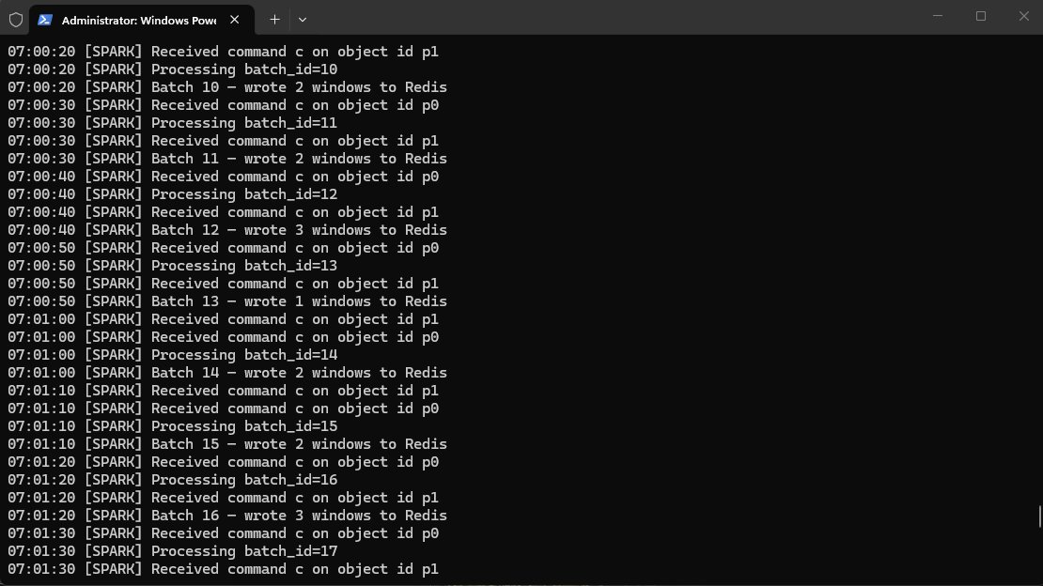

Screenshot 4 — Redis CLI: HGETALL showing California window with avg_aqi=78.77, band=Moderate, record_count=56
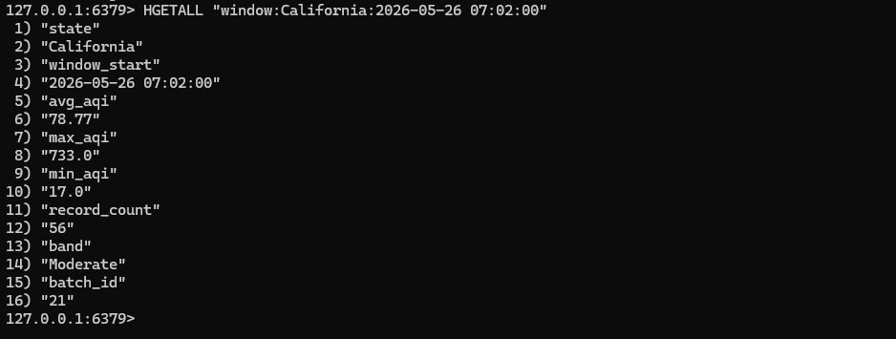

5. Task 3 — Watermarking and Late Data (6 Marks)

5.1 What is Watermarking?
In a real-time stream, events do not always arrive in the order they were generated. A sensor may go offline and send delayed readings when it reconnects. Without handling this, Spark would either wait forever for late data — consuming unbounded memory — or discard it silently.

PySpark's watermarking feature solves this by defining a threshold for how late data is allowed to be. The watermark boundary is:
watermark_boundary = max_event_time_seen - watermark_delay

Any event with an event_time below this boundary is dropped. Windows older than the watermark boundary are finalised and written to Redis.

5.2 Implementation
watermarked: DataFrame = parsed.withWatermark('event_time', '10 seconds')

5.3 Trade-off: Delay vs Completeness
Shorter Watermark (e.g. 5s) | Longer Watermark (e.g. 60s)
Lower memory usage | Higher memory usage
Faster results — windows close sooner | Slower results — windows stay open longer
More late events dropped | Fewer late events dropped
Less accurate aggregations | More accurate aggregations
Better for low-latency dashboards | Better for batch-accuracy requirements

A 10-second watermark is appropriate for this AQI monitoring pipeline. AQI data is not safety-critical in real-time, and a small amount of dropped late data has negligible impact on 30-second window averages.

Screenshot 5 — PySpark terminal: watermark configuration showing Tumbling window: 30 seconds | Watermark: 10 seconds
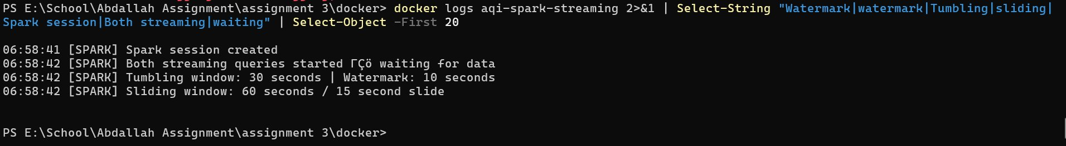

6. Task 4 — Streamlit Live Dashboard (8 Marks)

6.1 Objective
Build a Streamlit dashboard that reads processed windowed results from Redis and auto-refreshes every 5 seconds, providing a complete live view of the AQI data pipeline.

6.2 Dashboard Components
Section | Content
KPI Row | Total Records Processed, Global Avg AQI, Peak AQI, Active Windows, Dominant Band
Bar Chart | Avg AQI by State (latest window) — colour-coded by EPA band
Donut Chart | Classification Band Distribution (Good/Moderate proportions)
AQI Timeline | Line chart of avg AQI over tumbling window timestamps
Window Comparison | Grouped bar: Tumbling (30s) vs Sliding (60s/15s) per state
Results Table | Latest 20 window results with state, avg AQI, max AQI, records, band
Live Record Feed | Colour-coded scrolling feed of 10 most recent processed records

6.3 Auto-Refresh Pattern
time.sleep(REFRESH_INTERVAL) # wait 5 seconds
st.rerun() # rerun entire script from top

Screenshot 6 — Full Streamlit dashboard: KPI row, bar chart, donut chart. URL bar shows localhost:8501
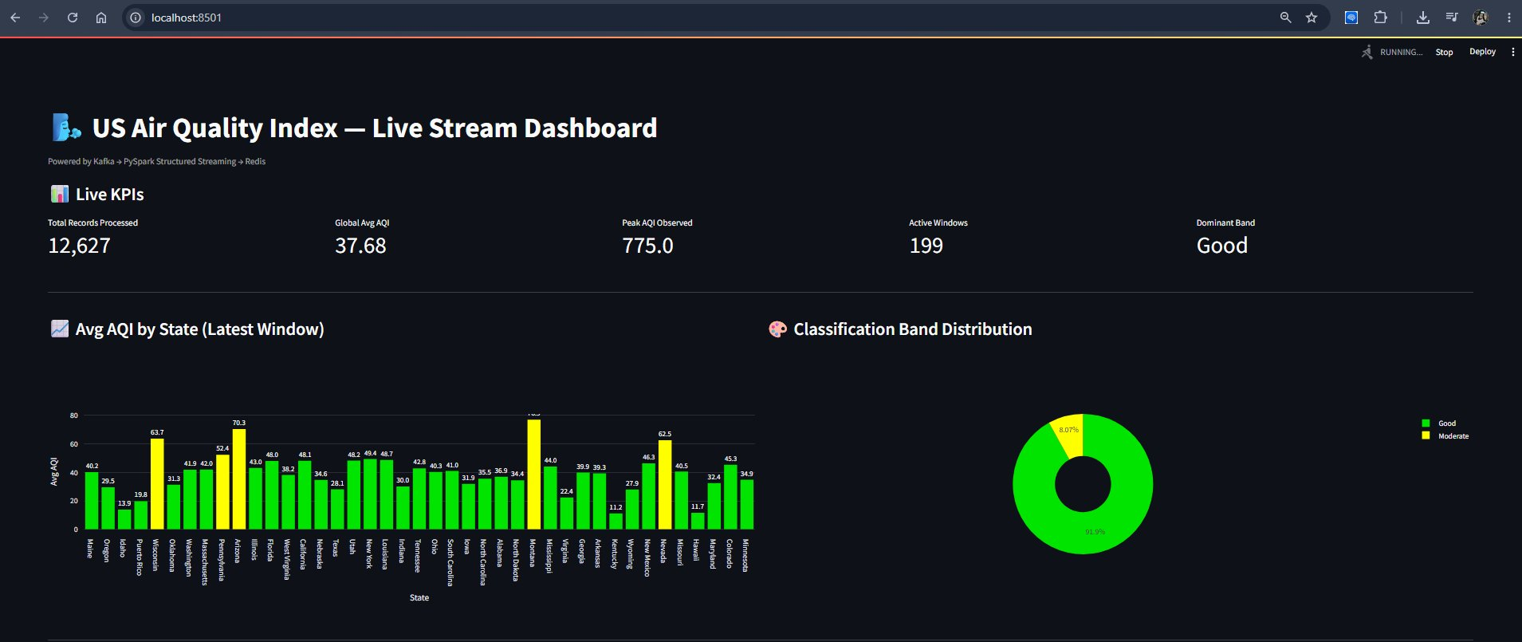

Screenshot 7 — Dashboard lower half: AQI timeline, tumbling vs sliding comparison, results table, live record feed
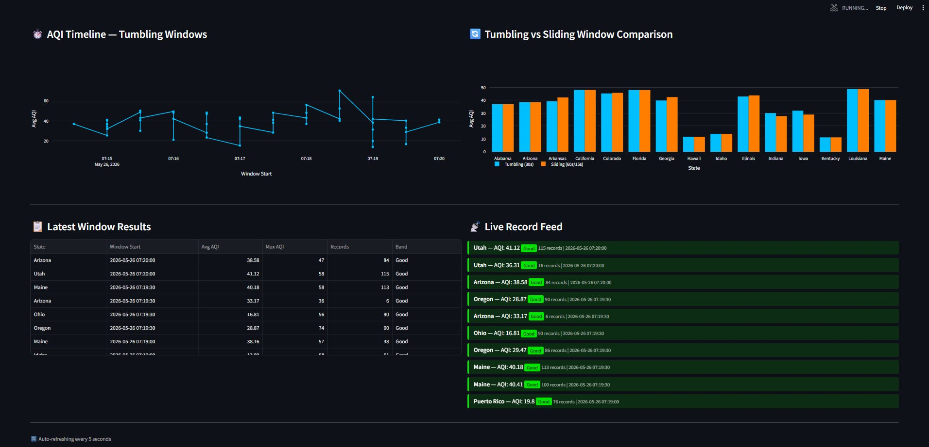

7. Bonus — Sliding Window Comparison (+3 Marks)

7.1 Implementation
A second streaming query uses a sliding window with 60-second duration and 15-second slide interval. Each event is included in up to 4 overlapping windows, producing smoother trend lines.
F.window(F.col('event_time'), '60 seconds', '15 seconds')

7.2 Tumbling vs Sliding Comparison
Property | Tumbling (30s) | Sliding (60s/15s)
Duration | 30 seconds | 60 seconds
Slide Interval | 30s (no overlap) | 15s (overlapping)
Events per Window | Each event in 1 window | Each event in up to 4 windows
Result Frequency | Every 30s | Every 15s
Smoothing | Less smooth | Smoother — overlapping averages
Memory Use | Lower | Higher (4x more state)

Screenshot 8 (Bonus) — Tumbling vs Sliding Window Comparison: blue (Tumbling 30s) vs orange (Sliding 60s/15s) per state


8. Analysis Questions

8.1 Streaming vs Batch Processing
Assignment 2 used PySpark in batch mode: the entire dataset was loaded once, processed, and the job terminated — producing a static snapshot. Assignment 3 uses PySpark Structured Streaming, which treats the Kafka topic as an infinite ever-growing table, processing new data every 10 seconds indefinitely.

What streaming reveals that batch cannot:
- Real-time anomalies — an AQI spike in a specific state is visible within 10-30 seconds, not hours later
- Time-based patterns — the AQI Timeline shows minute-by-minute evolution that batch collapses into a single average
- Live classification changes — a state moving from Good to Moderate mid-stream is only visible in streaming
- Window-level granularity — streaming gives a new result per group per 30 seconds; batch gives one result per group total

Where batch retains an advantage:
- Complex multi-pass analytics — batch can scan the full dataset multiple times; streaming processes each event once
- Global aggregations — computing all-time median AQI requires full dataset access, which batch handles naturally
- Reproducibility — batch results on the same data are deterministic; streaming results depend on arrival timing

8.2 Classification Output Analysis
The dashboard KPIs consistently showed Dominant Band as Good throughout the streaming session, with approximately 92% of records classified as Good and 8% as Moderate. No records reached Unhealthy or above during the observed windows.

Notable observations from the windowed classification output:
- California and Arizona consistently appeared in Moderate band windows — consistent with documented wildfire smoke and desert dust events in the Western US
- Midwest states (Iowa, Illinois, Indiana) predominantly appeared in Good band windows — consistent with lower industrial density
- The sliding window chart showed smoother band transitions compared to tumbling windows — confirming that 60-second overlapping windows reduce the impact of transient spikes
- No Very Unhealthy or Hazardous windows were observed — the dataset period did not include major air quality emergency events in the sampled cities

9. Marking Scheme

Assessment Criterion | Marks | Score
Task 1 — Replay producer publishes dataset to Kafka continuously with loop-back | 4
Task 2 — Streaming job parses JSON, applies windowed aggregations, classifies, writes to Redis | 10
Task 3 — Watermark correctly applied; late data handling explained in report | 6
Task 4 — Dashboard auto-refreshes with live data across all required sections | 8
Analysis — Both questions answered with clear reasoning and dataset-specific insight | 2
TOTAL | 30
BONUS — Sliding window query + side-by-side dashboard comparison | +3

